**Autumn/Winter 2024**

Issue

**Help us to help you by keeping your mobile number up to date**

To be able to communicate with patients quickly and efficiently we offer an SMS text messaging service.

We contact patients by SMS text message for many reasons including: test results, annual review invitations, immunisation invitations, reminders if you are due a blood test, links to book an appointment and appointment changes/cancellations.

If you change your mobile phone number please let us know by emailing:

[lscicb-csr.acreswood-surgery@nhs.net](mailto:lscicb-csr.acreswood-surgery@nhs.net) Alternatively you can complete an update details forms available in the surgery or contact reception.



Receive NHS health bulletins and practice information.

<https://www.facebook.com/people/Coppull-Medical-Practice/100063220720763/>

**RSV Vaccine**

The RSV vaccine helps to protect against respiratory syncytial virus (RSV), a common virus that can make babies and older adults seriously ill. The RSV virus can cause illness such as pneumonia and bronchiolitis.

It is recommened during pregnancy from 28 weeks and for adults aged 75 to 79 years.

The RSV vaccine can be given at any time of year, but we are encouraging older adults to be vaccinated before the Winter.

Older adults only require one vaccination. Pregnant ladies will require a vaccine with each pregnancy.

Eligible patients will be contacted by SMS text message, letter or telephone call. Patient’s are welcome to contact the surgery to arrange their vaccine.

We are holding winter vaccine clinics for flu and covid vaccines at Coppull Medical Practice and St John’s Church Hall.

All eligible patients will be invited by SMS text message, telephone call or letter.

Please contact the surgery to arrange your appointment or book using the text link.

**Winter Vaccines**

**Coppull Medical Practice**

**Focus on Frailty**

‘Frailty’ is a term that’s used a lot, but is often misunderstood. When used properly, it refers to a person’s mental and physical resilience, or their ability to bounce back and recover from events like illness and injury. (Age Concern, 21/7/20)

If someone is living with frailty, it doesn’t mean they lack capacity or are incapable of living a full and independent life. When used properly, it actually describes someone's overall resilience and how this relates to their chance to recover quickly following health problems. (Age Concern, 21/7/20)

A frailty assessment consists of asking the individual a series of questions, which helps to determine if they are not frail, mildly frail, moderately frail or severely frail. The assessment is carried by a member of our nursing team or our care co-ordinator.

Historically, an individuals level of frailty is usually assessed once they are aged 65 years or older. However, in Central Lancashire GP practices are now assessing an individual’s level of fraility from age 50 years.

The aim of assessing frailty earlier is to identify individuals with mild or moderate frailty. By identifying frailty sooner, a plan can be agreed with the individual to address health or social care issues, which can then reduce their level of frailty or prevent frailty increasing. This can help to improve health and quality of life in older age.

Some individuals have felt uneasy when frailty has been discussed with them, particulary if they are leading an independent life. We would like to reassure patient’s that having a frailty assessment does not mean that you are frail. It simply means that you would benefit from an assessment to determine if you have any level of fraility, that would benefit from early intervention.

You may be contacted by the care co-ordinator to undertake a frailty assessment. The nurse may also undertake a frailty assessment at your chonic disease annual review.

**If you would like to book a frailty assessment, please contact reception.**

If you would like to join our Patient Participation Group please email your details to [lscicb-csr.acreswood-surgery@nhs.net](mailto:lscicb-csr.acreswood-surgery@nhs.net)

Alternatively, you can speak to a receptionist or complete a form available in surgery.

Meeting minutes are available on the practice website: [www.coppullmedicalpractice.co.uk](http://www.coppullmedicalpractice.co.uk)

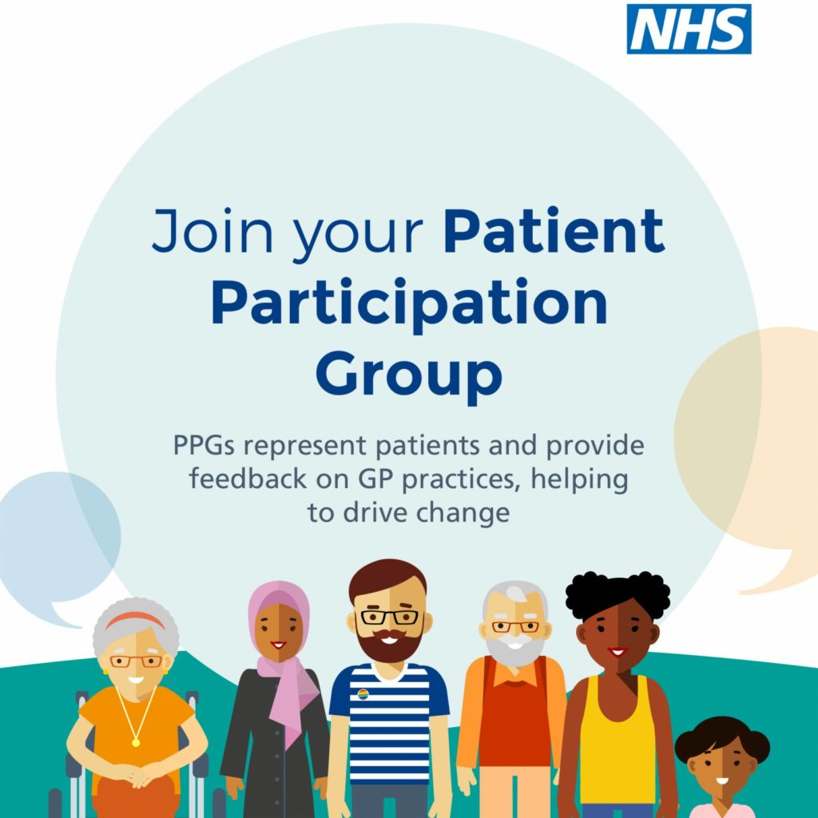

**Patient Participation Group**

**LANCASTER MEDICAL SCHOOL**

**Advanced Nurse Practitioner (ANP)**

Your Advanced Nurse Practitioner can assess and prescribe for many different health conditions and minor illnesses. They can order tests and make a referral to a specialist.

**Practice Nurse**

Your Practice Nurse can support and advise you with management of a long-term condition. They also offer services to keep you well such as vaccinations and cervical smears.

**Mental Health Practitioner**

Your Mental Health Practitioner can provide advice, guidance and intervention for those who do not fulfil the criteria

for specialist mental health

services.

**Social Care Prescriber**

Your social prescriber helps to reduce health inequalities by supporting you to unpick complex issues affecting your wellbeing. They can help you access services to improve your overall wellbeing.

**Associate Psychological Practitioner (APP)**

Your Associate Psychological Practitioner offers structured brief intervention for low level mental health difficulties.

**Care Co-Ordinator**

Your Care Co-Ordinator is a non-medical member of the team. Their role is to support you if you have complex needs and would benefit from assistance navigating health and social care services.

**YEAR 5 MEDICAL STUDENTS**

**We are excited to announce that we are now working with Lancaster University as a medical student teaching practice.**

We are providing 7-week placements for year 5 medical students, so they can gain experience within a GP practice.

These are the doctors of the future; we think it's important that they learn about general practice, as there is a national shortage of GP’s.

**What does this mean for patients?**

* The medical student may be working with the healthcare professional you have an appointment with.
* The medical student may be involved in assessing your case, with the support of their GP trainer.
* We encourage patients to allow the medical student to be involved in their care, as this helps to train future doctors.
* If you do not want the medical student to be present during your consultation or to assess your case, please notify a member of the reception/care navigation team.

Thank you for taking the time to read our newsletter.

If you would like to suggest any topics to include in future newsletters please email us at: [lscicb-csr.acreswood-surgery@nhs.net](mailto:lscicb-csr.acreswood-surgery@nhs.net)